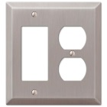
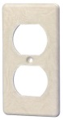
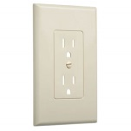
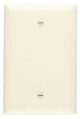
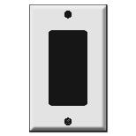
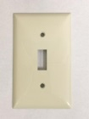
♥♥♥♥♥♥ CUSTOM ORDER KNOWLEDGE ♥♥♥♥♥♥
♥Custom decoupage orders take about 1- 2 weeks to create. However RUSH orders are available. Simply email me to set up the details.
♥This product is not recommended for outdoor or humid spaces. This is a paper decoupage craft piece that is meant for indoor and dry environments only.
♥Not all prints are available for custom orders. Please see each individual listing for available sizes.
PRICE LIST:
Basic Toggle Light Switch Covers
(BT)Single $10
(BT2) Double $12
(BT3) Triple $14
(BT4) Quad $16
Rocker Style Covers - Used for light switch covers and/or outlets
(R1) Single $10
(R2) Double $12
(R3) Triple $14
(R4) Quad $16
Outlet Covers
(O1) Single $10
(O2) Double $12
Blank Covers
(BC) Single $10
(BC2) Double $12
Double Combo Covers
(DC) $12

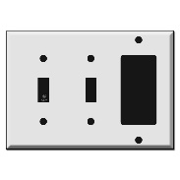
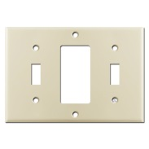
Triple Combo Covers
(TC) $20

